Batch1: 05-01-24

Batch2: 06-01-24

**Experiment No.2**

Title: To Implement a program using conditional logic.

Aim: To Implement a program using conditional logic and various loops.

Softwares Used: Visual Studio Community Edition 2022

Lab Outcomes:

Students will be able to:

1. To Implement a program using conditional logic.

Theory:

* Types of ifs, types of loop, switch…case

Problem Statement#1: Write a C# program to calculate Electricity bill for the consumer. Enter consumer number, name and units from keyboard. (Use while loop)

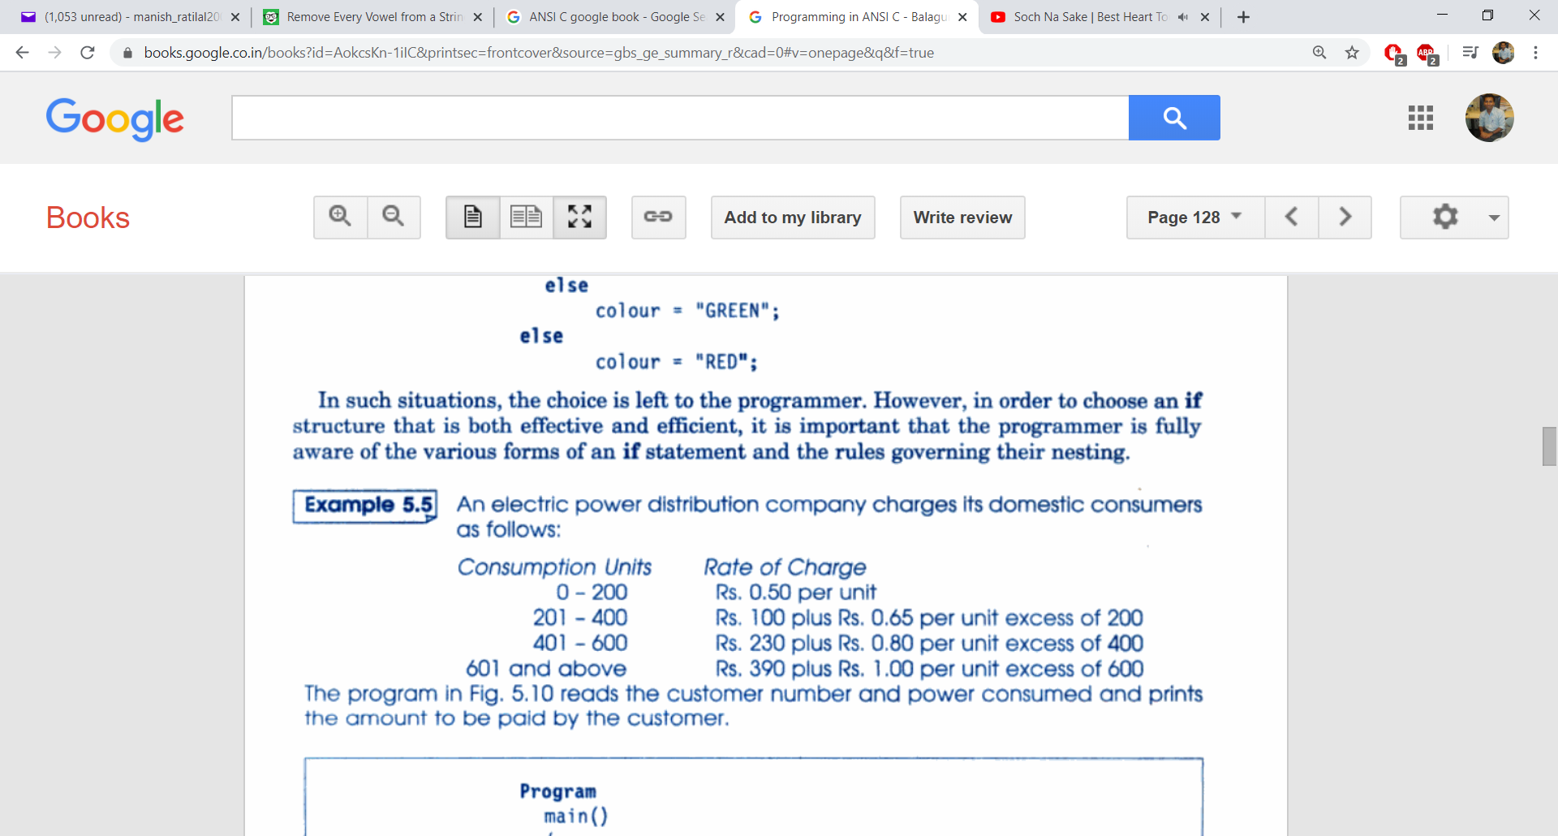

Consider 3% State Govt. tax and 2% central Govt. tax in the total bill.

Source Code:

Output:

Problem Statement#2: Write a C# program to calculate the net salary of n number of employees as per given problem. (Use switch case & for loop)

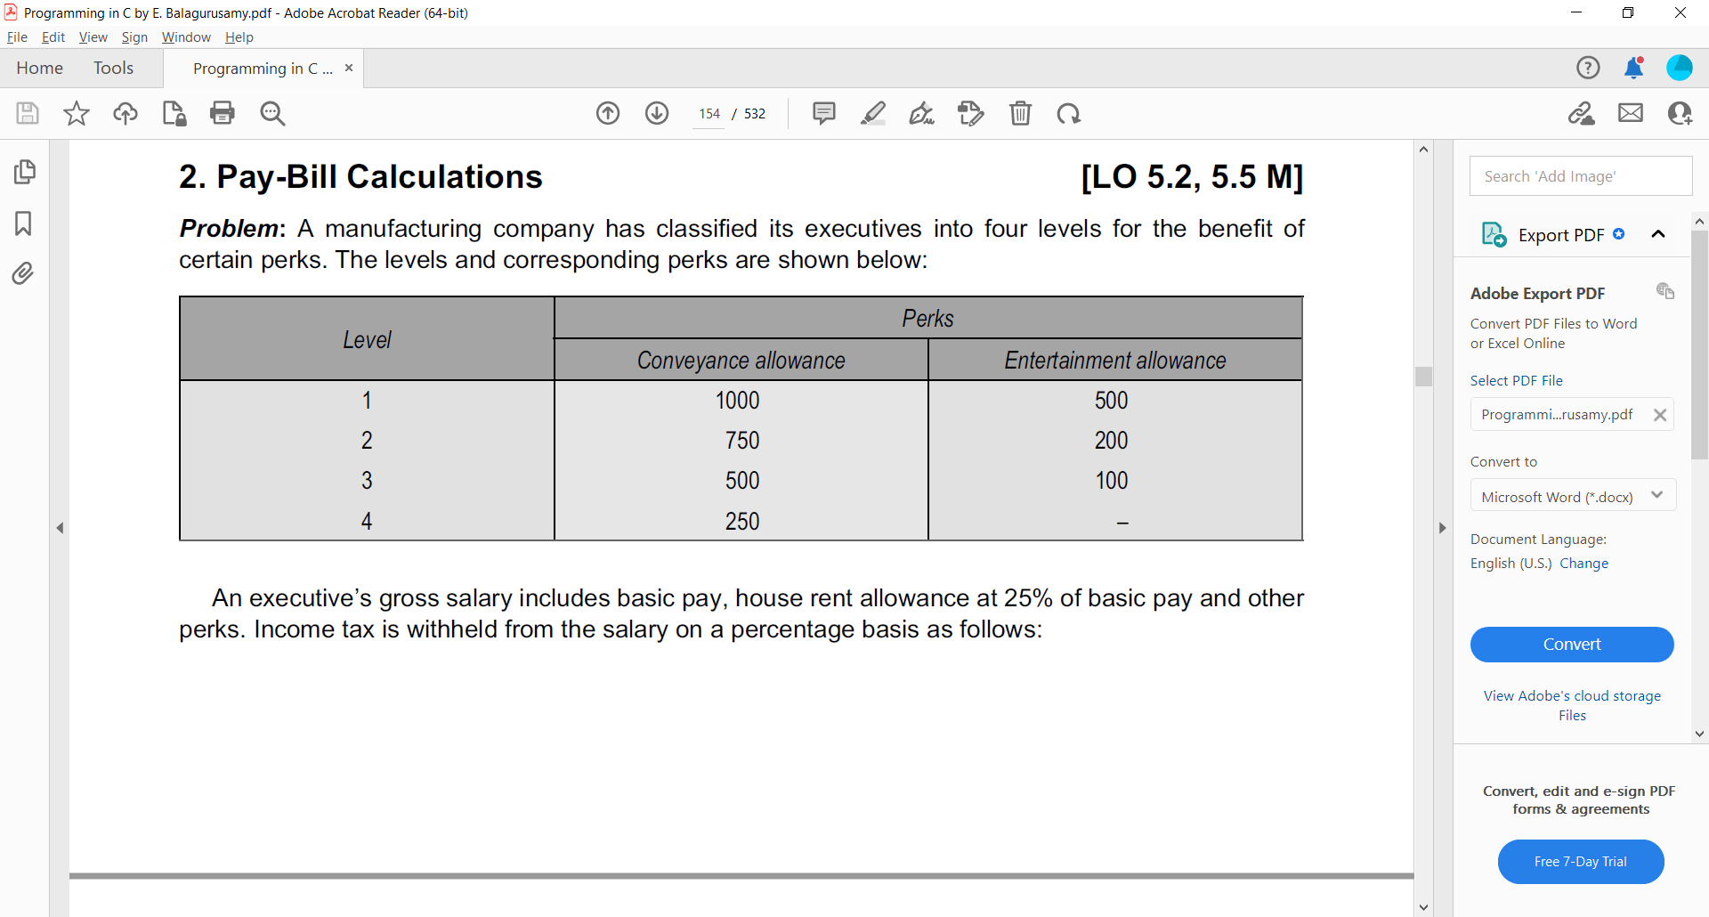

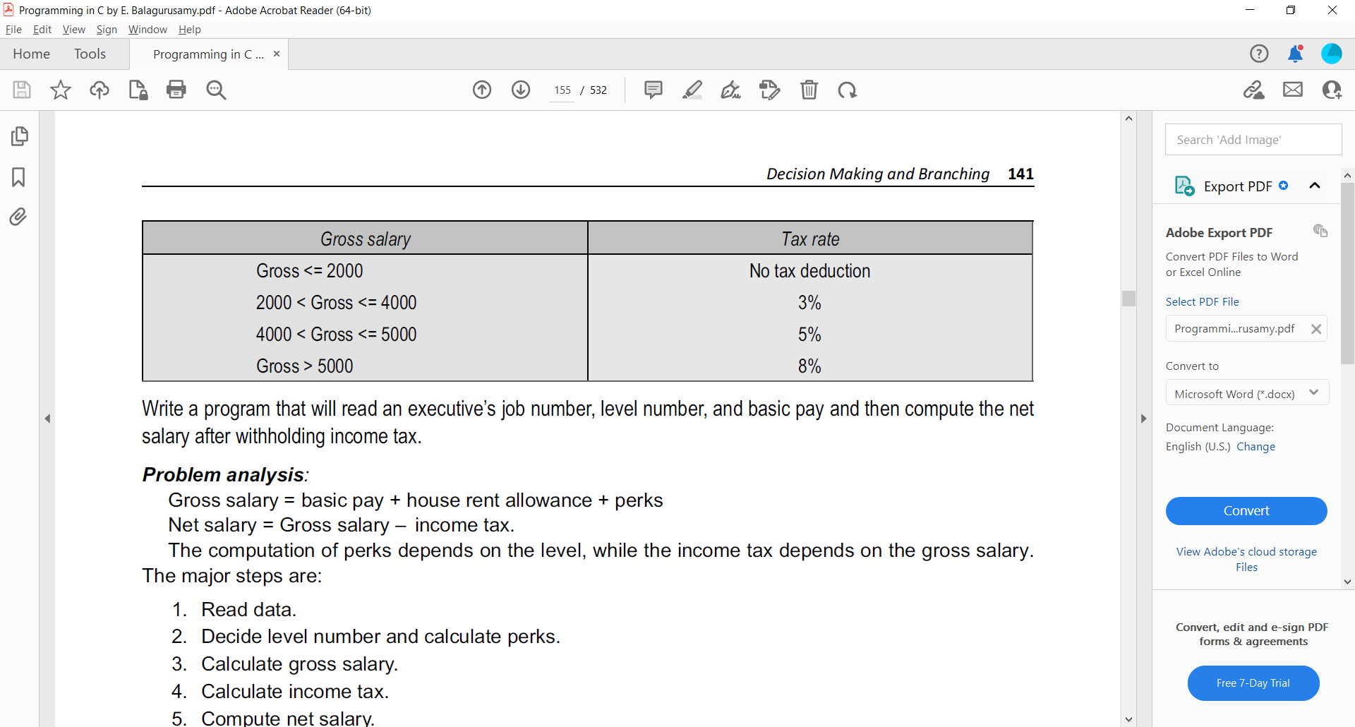

Source Code:

Output:

Conclusion: